Python Assignment 01

248518

Gaurav B Raskar

1. A computer’s components include the CPU, RAM and I/O devices.
2. I don’t have a physical laptop or mobile device.
3. Pc🡪 i5 4th mobile -> snapdragon 680 laptop-> i5 10th gen
4. Read Documnetation
5. Different Python implementations include CPython, Jython, IronPython, and PyPy; we use CPython.
6. Python was created by “Guido van Rossum” in 1991 in the Netherlands.
7. PVM stands for Python Virtual Machine, which executes Python bytecode.
8. Python is platform-independent and can run on Windows, macOS, Linux, and others.
9. Python is platform-independent because it uses a virtual machine to execute code, making it adaptable to different systems.

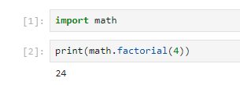\

11.

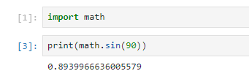

12.

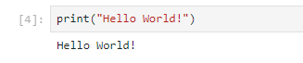

13.

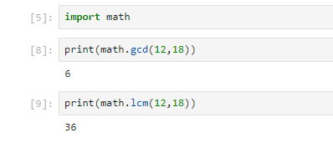

14.

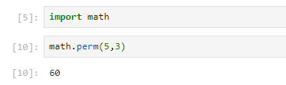

15.

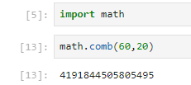

16.

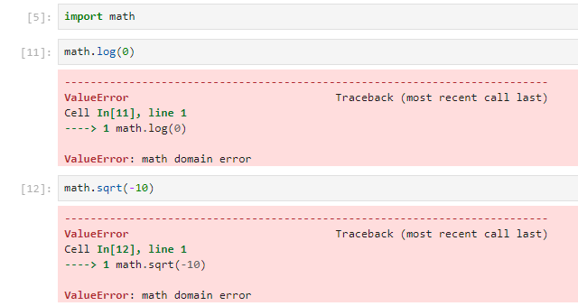Top of Form

17.

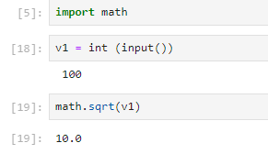

18.

Internally the reason that Python code executes more slowly is because code is interpreted at runtime instead of being compiled to native code at compile time.

19.

Bottom of Form